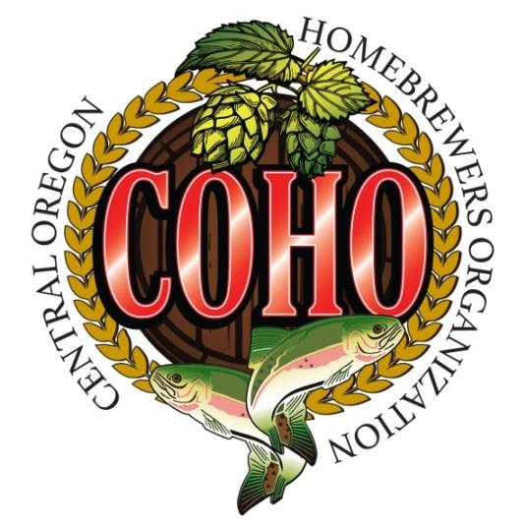

COHO Summer Shandy Challenge

New for the 2023 Club Competition is the Introduction of the Beer Cocktail as a People’s Choice-only event. This challenge will add to the fun at our Annual Summer Camp-out.
Since Beer Cocktails do not fall under any BJCP Guidelines (nor will they ever) and this year is the first time we are doing this, here is a little background, suggestions, and few simple rules for the summer shandy challenge:
What is a Shandy? A shandy is a British beer cocktail usually made of equal parts beer and citrusy soda. A shandy can be easily customized with the beer and soda/tea of your choice. The Germans have a similar drink called a radler. For our competition you are not limited to citrus soda but can use any fruit or herbal (e.g. Ginger Ale) soda (mostly) or tea. The goal is a light refreshing low alcohol drink of about 2-4% ABV.
Suggested Beer Styles: Shandies do best when made from a light malt base beer that supports the fruit/herbal flavors. Try to stay away from dark beers (e.g. Stouts, Porters, Bocks) or highly hoppy beers (e.g. Double IPAs, Hazy) as they tend to overwhelm the lighter flavors. Suggested base styles include Pale Ales, Pilsners, Hefeweizen or Wheat Beers, Cream Ales, American Lagers, Kolsch, IPAs (single, not doubles).
Some Suggested General Flavor Pairings:
- Citrus Fruits – Pale Ales, Wheat Beers, Cream Ales
- Berry/Pomme (Apple, Peach etc.) – Lagers, Cream Ales, Pilsners, Pale Ales
- Herbal Flavors – IPAs
Suggested Beer / Flavor Ratios: Between 1/3- 1/2 Soda/Tea to 2/3-1/2 beer ratio to taste .

Rules For COHO Summer Shandy Challenge
- All Entries must be bottled. Technically a Shandy can be mixed when served but for the river float mixing them would be a recipe for disaster. Mix your soda in your beer during secondary or when you bottle.
- Base beer must be home-brewed, but the soda/tea is up to you and can be a commercial product.
- Please bring three (3) 22oz bombers to have enough for everyone at the camp-out to taste. You are welcome to bring additional for sharing later.
- Please register your entry (including Shandy name, base beer & soda) with either Pete or Bobby by July 17th. There is no entry fee or forms required, just a commitment to bring the bottles to the campout.
- Best named entry – There will be a special one-time award of 1 extra point towards COHO Brewer of the year award for the best named Shandy
Any questions, praise, or condemnations should be directed to Pete Ostner at postner15@gmail.com.

